SET 16: CUSTOMER DEMOGRAPHICS ANALYSIS

Dataset | Customer Demographics
Department | AIDS
Course Code / Course Name | DSA0602 / Data Handling and Visualization
Experiment | Data Visualization using R
Name | GOPIKHA S
Register Number | 1924260143
Date | 10 October 2026
Day | Saturday

Dataset: Customer Demographics

Customer ID | Age | Gender | Income (in $)
1 | 28 | Female | 50000
2 | 35 | Male | 60000
3 | 42 | Female | 75000

PROGRAM 1: Bar Chart of Customer Ages
Question: Create a bar chart to visualize the distribution of customer ages. Label the axes and title the chart.
# Dataset
customer_id <- c(1, 2, 3)
age <- c(28, 35, 42)

# Bar Chart
bp <- barplot(age,
names.arg = customer_id, main = "Customer Ages", xlab = "Customer ID", ylab = "Age",
col = "skyblue")

# Label each bar
text(bp, age, labels = age, pos = 3)

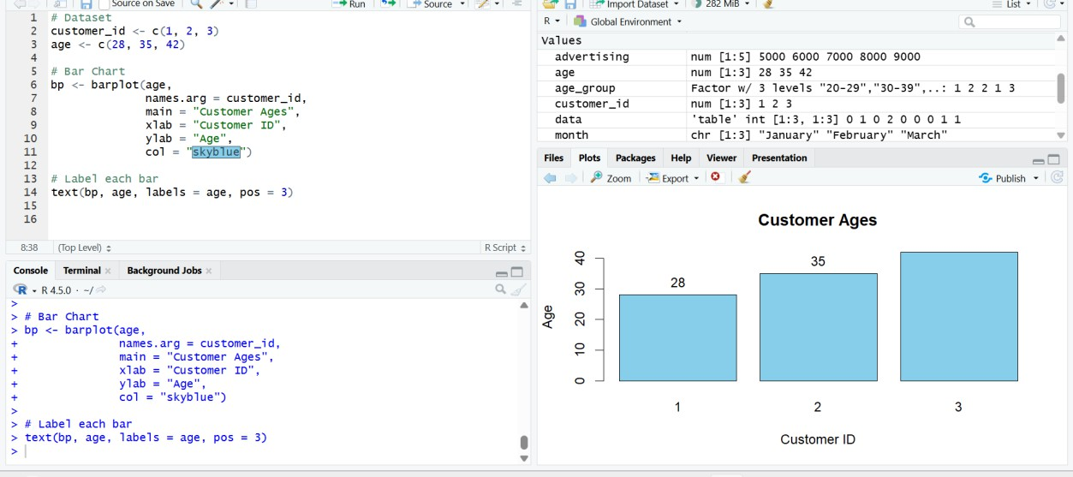

Output 1: Customer Ages Bar Chart
Observation: The bar chart represents the ages of the three customers. The ages are 28, 35, and 42 years for Customer IDs 1, 2, and 3 respectively.

PROGRAM 2: Pie Chart of Customer Gender
Question: Generate a pie chart to represent the distribution of customers by gender.
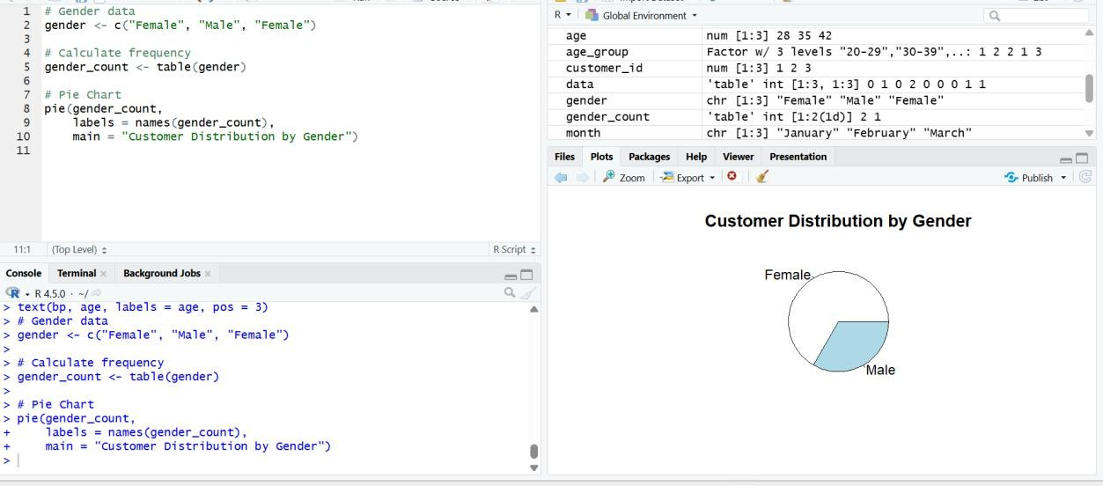
# Gender data
gender <- c("Female", "Male", "Female")

# Calculate frequency gender_count <- table(gender)

# Pie Chart pie(gender_count,
labels = names(gender_count),
main = "Customer Distribution by Gender")

Output 2: Customer Distribution by Gender Pie Chart
Observation: The pie chart shows that there are 2 female customers and 1 male customer in the given dataset.

PROGRAM 3: Customer Demographic Information Table
Question: Build a table to show the demographic information for each customer. Label the table elements.
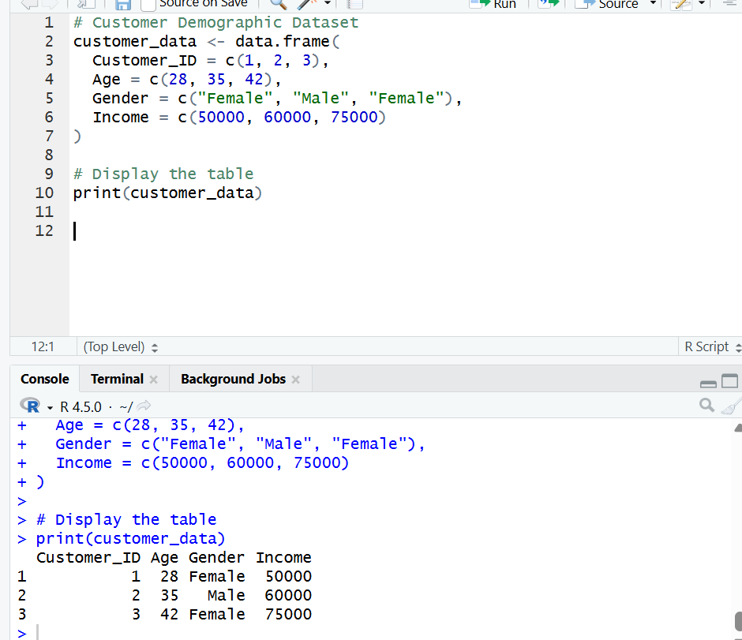
# Customer Demographic Dataset customer_data <- data.frame(
Customer_ID = c(1, 2, 3),
Age = c(28, 35, 42),
Gender = c("Female", "Male", "Female"), Income = c(50000, 60000, 75000)
)

# Display the table print(customer_data)

Output 3: Customer Demographic Information Table
Observation: The table displays the Customer ID, Age, Gender, and Income for each of the three customers.

PROGRAM 4: Interactive Tableau Dashboard
Question: Develop a Tableau dashboard combining the bar chart, pie chart, and the table for interactive exploration of customer demographics.

Tableau Steps
- Open Tableau and connect to the Customer Demographics dataset.
- Verify the fields Customer ID, Age, Gender, and Income.
- Create a new worksheet for the Customer Ages bar chart.
- Drag Customer ID to Columns and Age to Rows, then select Bar in the Marks card.
- Add the title “Customer Ages” and label the axes.
- Create another worksheet for the gender pie chart.
- Drag Gender to the view and use Number of Records (or COUNT(Customer ID)) as the measure; select Pie from the Marks card.
- Create a third worksheet and drag Customer ID, Age, Gender, and Income into the view to form the demographic table.
- Create a new Dashboard and add the bar chart, pie chart, and table.
- Add the title “Customer Demographics Dashboard”.
- Use the pie chart or a suitable field as a filter where appropriate to make the dashboard interactive.
- Test the dashboard by selecting a gender/category and checking the linked views.
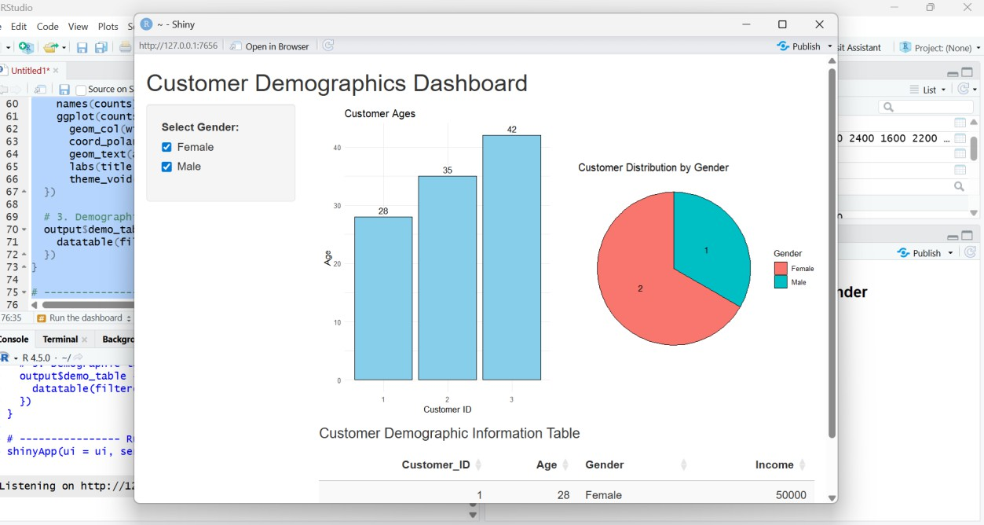

Output 4: Customer Demographics Dashboard
Observation: The Tableau dashboard combines the customer age bar chart, gender pie chart, and demographic table, allowing interactive exploration of the supplied customer information.

Procedure
- Create the customer demographic data in R.
- Prepare the customer age values and create the bar chart using barplot().
- Prepare the gender data, calculate frequencies using table(), and create the pie chart using pie().
- Create a data frame containing Customer ID, Age, Gender, and Income and display it as a table.

- Open Tableau and import the Customer Demographics dataset.
- Create the customer age bar chart and gender pie chart in Tableau.
- Create the demographic information table in Tableau.
- Combine the three visualizations into an interactive dashboard and add a suitable title.
- Test the dashboard using the available filter/interactivity.

Result
The Customer Demographics data was successfully visualized using a bar chart, pie chart, demographic information table, and an interactive Tableau dashboard.

